**RESILIENT AQUATIC FOOD SYSTEMS FOR   
HEALTHY PEOPLE AND PLANET PROJECT**

**FIELD SURVEY REPORT**

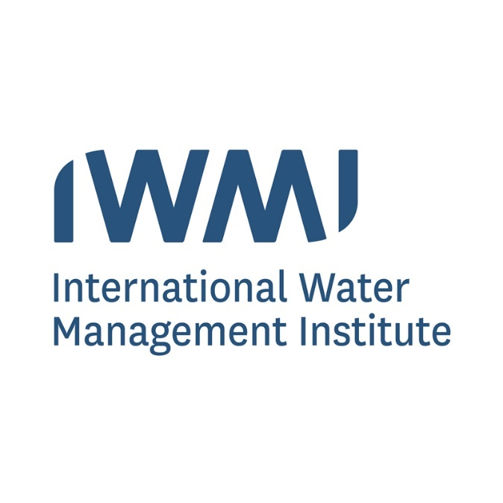

Mary Amponsah (Consultant)

December 2022

Contents

**1.** **BACKGROUND** 4

**2.** **METHODOLOGY** 4

**3.** **SURVEY DESIGN** 5

**4.** **SURVEY IMPLEMENTATION** 6

**5.** **RESULTS** 6

**5.1** **NALERIGU DAM** 6

**5.1.1** **RESERVOIR CHARACTERISTICS** 7

**5.1.2** **RESERVOIR USES AND USERS** 7

**5.1.3** **RESERVOIR WATER QUALITY** 8

**5.2** **LANGBENSI DAM** 8

**5.2.1** **RESERVOIR CHARACTERISTICS** 8

**5.2.2** **RESERVOIR USES AND USERS** 9

**5.2.3** **RESERVOIR WATER QUALITY** 10

**5.3** **NANSONI DAM** 11

**5.3.1** **RESERVOIR CHARACTERISTICS** 11

**5.3.2** **RESERVOIR USES AND USERS** 12

**5.3.3** **RESERVOIR WATER QUALITY** 12

**5.4** **TOMBU DAM** 12

**5.4.1** **RESERVOIR CHARACTERISTICS** 12

**5.4.2** **RESERVOIR USES AND USERS** 13

**5.4.3** **RESERVOIR WATER QUALITY** 13

**5.5** **DIANI DAM** 14

**5.5.1** **RESERVOIR CHARACTERISTICS** 14

**5.5.2** **RESERVOIR USES AND USERS** 15

**5.5.3** **RESERVOIR WATER QUALITY** 15

**5.6** **NAYORKO DAM** 16

**5.6.1** **RESERVOIR CHARACTERISTICS** 16

**5.6.2** **RESERVOIR USES AND USERS** 17

**5.6.3** **RESERVOIR WATER QUALITY** 17

**5.7** **CHEREPONI DAM** 18

Figures

**Figure 1. Selected reservoirs for the field survey. 4**

**Figure 2. Percentage of responses to the community–level organization in Nalerigu. 7**

**Figure 3. Fish cage farming in the Nalerigu reservoir. 8**

**Figure 4. Percentage of responses to the community–level organization in Langbensi. 9**

**Figure 5. Response on the level of security in the Langbensi community. 10**

**Figure 6. Washing activities and irrigation using a water pump at the Langbensi dam. 11**

**Figure 7. Percentage of responses to the community–level organization in Nansoni. 12**

**Figure 8. A picture of the Nansoni dam. 13**

**Figure 9. Percentage of responses to the community–level organization in Tombu. 14**

**Figure 10. A picture of the Tombu dam. 15**

**Figure 11. Percentage of responses to the community–level organization in Diani. 16**

**Figure 12. A picture of the Diani dam 17**

**Figure 13: Percentage of responses to the community–level organization in Nayorko. 19**

**Figure 14. A picture of the Nayorko dam 20**

**Figure 15. Pictures of the Chereponi dam 21**

Tables

**Table 1. Reservoirs and dams are presented for possible fish cage culture*.* 5**

**Table 2. Field survey design-based questions. 5**

**Table 3. Sample results on the characteristics of the Nalerigu reservoir. 7**

**Table 4. Sample results on the characteristics of the Langbensi dam. 9**

**Table 5. Sample results on the characteristics of the Nansoni dam. 12**

**Table 6. Sample results on the characteristics of the Tombu dam. 14**

**Table 7. Sample results on the characteristics of the Diani dam. 16**

**Table 8. Sample results on the characteristics of the Nayorko dam. 18**

Abbreviations

**NA No Answer**

**ROSCA Rotating Savings and Credit Association**

# **BACKGROUND**

This field study was executed as part of the activities for the WP3 of the Aquatic Foods Initiative under the Resilient Aquatic Food and Systems for Healthy People and Planet project, to support the multi-functionality of the water bodies and strengthen food security, poverty reduction, women and youth empowerment.

The goals of the field survey were to collect data along three thematic areas: the characteristics of the reservoir, the reservoir uses and users, and the water quality of the reservoirs. The results will support the final selection of the pilot sites for the project.

# **METHODOLOGY**

From the preliminary results from mapping the monthly extent of small reservoirs in the North East region of Ghana using Sentinel 2 satellite imagery in the Google Earth Engine Environment, eight (8) out of seventeen (17) reservoirs presented by the CSIR Water Research Institute were selected for field observation and their suitability for possible fish cage culture.

The reservoirs were selected based on the area and availability of water in the dry seasons (November to April). Data for the periods, November 2021 to February 2022 were used for the selection for the field survey. The reservoirs ranged from 3 to 27 in size hectares through the seasons specified.

The locations of the eight reservoirs within the North East region are shown in Figure 1 and the information on their area dynamic is in Table 1.

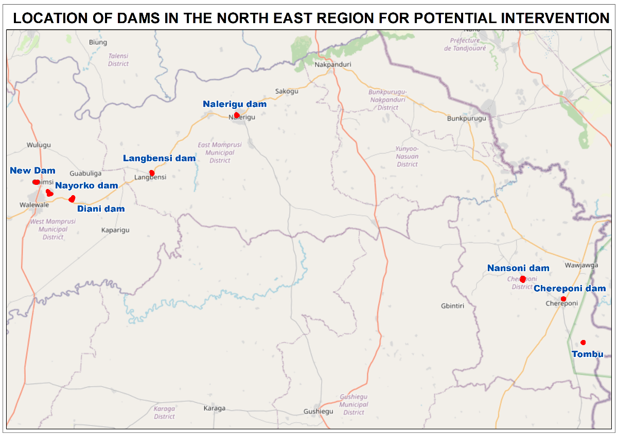

Figure 1. Selected reservoirs for the field survey.

Table 1. Reservoirs and dams are presented for possible fish cage culture*.*



# **SURVEY DESIGN**

The consultant designed a questionnaire which was presented for review to the project team members for their comments and suggestions. This was to ensure the questionnaire covered all the relevant details and was suitable and easy to implement in the field.

The questionnaire covered three main thematic areas: the characteristics of the reservoir, the reservoir uses, and users, and the water quality of the reservoirs. The questions covered are described in Table 2.

The finalized survey forms were uploaded to the KoboToolbox server and the application was installed on tablets and tested.

Table 2. Field survey design-based questions.

|  |
| --- |
| **Reservoir Characteristics**  Name and alias of the reservoir, location, size, depth and velocity, availability of water year-round, year of development, ownership, funders, management, accessibility to electricity and local markets, surrounding communities dependent on dams, existing community-level organizations, security measures, and the possibility of reservoirs flooding in the wet season. |
| **Reservoir Use and Users**  Multiple uses of the reservoir, number of users per day, existing or past aquaculture system and status, fishing activities, and type of fish species. |
| **Reservoir Water Quality**  Activities that affect the quality of water, quality issues experienced or reported by users, sanitation around and close to the reservoirs, use of detergent for washing in dams, sediment challenges, and access to historical water quality parameters. |

# **SURVEY IMPLEMENTATION**

The field surveys were carried out from the 14th to the 18th of November 2022. The survey team was made up of eight members; the IWMI Consultant, a representative from IWMI, two representatives from CSIR – Water Research Institute, and two representatives from the Fisheries Commission. Two other staff from the Fisheries Commission in Walewale joined the team for the exercise.

The team in Walewale contacted the officers in the various communities where these dams were situated to inform the chiefs and community overlords about our intended visits and seek permission to carry out the surveys.

Upon arrival at the communities, the team met with the chiefs or overlords and the elders of the community. A brief of the project background and objectives was shared and permission was sought to interview some members of the community.

The interview was intended to be gender balanced, looking at interviewing a minimum of six persons per community, three males and three females. Four team members were in charge of collecting the data and the team from Walewale helped with the language interpretation. The KoboCollect application was used for collecting the survey data.

# **RESULTS**

The team interviewed a total of forty-seven (47) respondents, of which 26 were males, and 21 were females in seven (7) communities where the reservoirs are located. The New Dam reservoir located in Gbemsi in the West Mamprusi district was not visited due to the inaccessibility of the road to the reservoir and community.

The occupations of the respondents included fishermen, farmers, fishmongers, traders, politicians, teachers, brickmakers, carpenters, electricians, teachers, hairdressers, seamstresses, housewives, and students.

For the dams visited, the chiefs and the elders of the communities warn the team of the presence of crocodiles in all the dams.

The results of the seven dams are summarized below.

## **NALERIGU DAM**

The Nalerigu dam is located in Nalerigu in the East Mamprusi district of the North East region of Ghana. A total of 8 respondents, 6 males, and 2 females were interviewed. The community refers to the reservoir as ‘Birimi’ which means ‘river water’ in their local dialect.

Surrounding communities that also benefit from the dam include, Gambaga, Zarantina, Nagbo, Buipere, Dentege, Namore, Atabia, and Kuligudori.

### **RESERVOIR CHARACTERISTICS**

From the survey, the community headed by the Overlord oversees the Nalerigu dam and it is managed by the Overlord or Chief and his elders. The estimated depth of the dam ranges between 23 – 42 feet. The dam does not dry up throughout the year and 62% of the respondents acknowledged to dams not flooding in the rainy season. The community has access to electricity and there is a local market within the community. The majority 42% of the respondent acknowledged the existence of Women’s groups in the community. Other community-level groups are shown in Figure 2.

Table 3. Sample results on the characteristics of the Nalerigu reservoir.



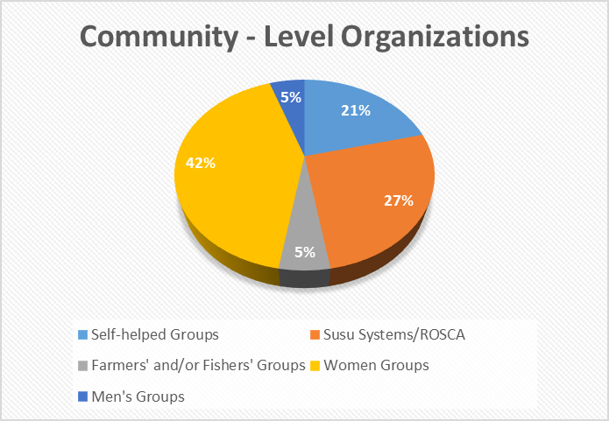

Figure 2. Percentage of responses to the community–level organization in Nalerigu.

### **RESERVOIR USES AND USERS**

The reservoir serves the following purposes to the community; aquaculture practices, construction purposes, domestic uses, source of water for drinking, fishing, irrigation, and brick making. Approximately, 50 to 300 users access the reservoir per day. There is active fish cage farming in the reservoir. From time to time, fishermen within the community and neighboring communities are given authorization by the chief or overlord to fish in the reservoir. Some of the fishes harvested include Tilapia, Catfish, Citharinus, Synodontis, Mormyrus, Bricinus nurse, Small Clupeids, Mormyridae, and Tilapia Zilli. Per the survey, the level of security is high and safe for fish farming.

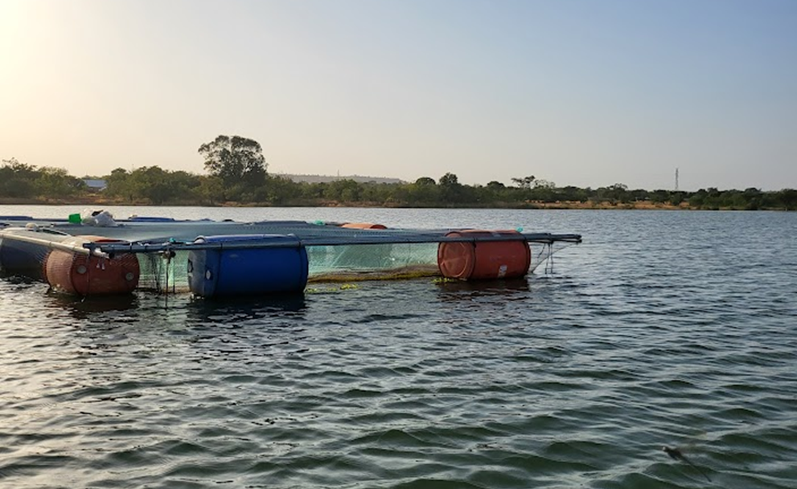

Figure 3. Fish cage farming in the Nalerigu reservoir.

### **RESERVOIR WATER QUALITY**

From the survey, the community discourages indigenes from washing especially with detergents in the dams as it serves as a source of drinking water for the communities. The presence of upstream water, agriculture activities, brick-making close to the reservoir, and construction causes the reservoir to be silted especially at the edges. Surface runoffs from rainfall are the major cause of sedimentation. Open defecation and disposal of rubbish close to the reservoir are some of the sanitation challenges faced.

## **LANGBENSI DAM**

The Langbensi dam is situated in Langbensi in the East Mamprusi district, North East region. Five males and five females, making up to 10 people, were interviewed from this community. The dam is generally referred to as ‘Langbensi moare or Langbensi dam’. Bunbuazio, Tangbini, Bawku, and Kasaphe communities also benefit from the dam.

### **RESERVOIR CHARACTERISTICS**

The dam constructed by the government under Kwame Nkrumah’s regime is managed by the chief and the elders of the community as given by the majority of the respondents. The dam does not dry up completely in the dry season. Six out of ten respondents acknowledged the flooding of the dam in the rainy season. It was added that, though the dam floods, the communities are not affected by the flooding of the dam. The estimated depth ranged from 20 to 60 feet. The community has access to electricity and a local market. Susu systems and women’s groups had the highest tally. Other community-level organizations mentioned were the self-helped groups, men’s groups, and farmers’ and fishermen’s groups.

Table 4. Sample results on the characteristics of the Langbensi dam.



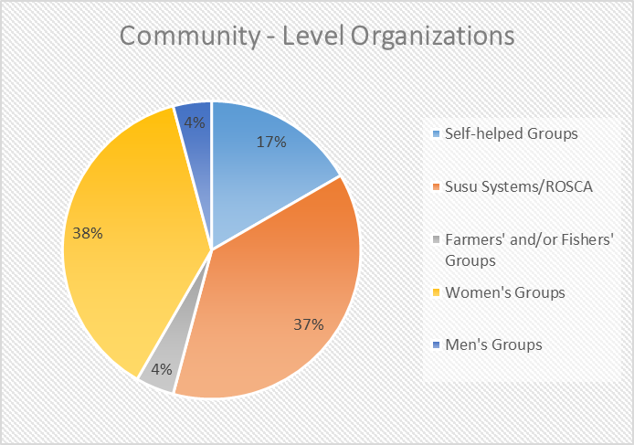

Figure 4. Percentage of responses to the community–level organization in Langbensi.

### **RESERVOIR USES AND USERS**

With approximately 30 to 100 users per day, the water from the dam is mainly used for Irrigation, Fishing, Domestic Uses, Construction, and Watering of animals such as cattle. There has not been any initiative of aquaculture practices in the dam but fishermen from other communities are given authorization from time to time by the chief or overlord to harvest fish from the dam. Some common fish harvested are, Catfish, Tilapia, Mormyridae, Synodontis, Mudfish, and Crabs, amongst others. Figure 5 describes the level of security in the community.

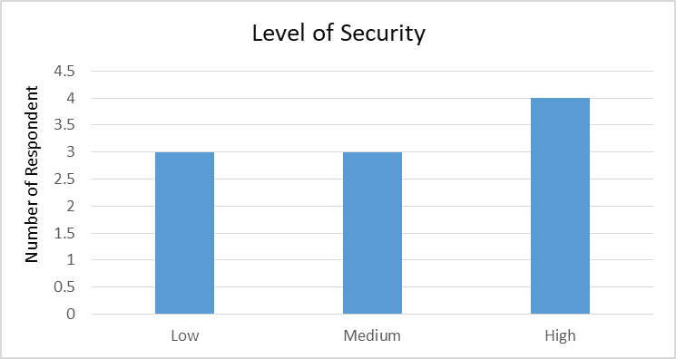

Figure 5. Response on the level of security in the Langbensi community.

### **RESERVOIR WATER QUALITY**

Washing in the dams with detergent is a common practice in the community. Some mentioned natives leaving worn-out clothes around the dam after washing. There are farms close to the dam that use the water for irrigation. The presence of upstream water, agriculture activities, and construction activities close to the dam causes the dam to be silted. Surface runoffs from rainfall are the major cause of sedimentation. Domestic waste, defecation, disposal of rubbish, fertilizer containers, and washing products close to the dam are some of the sanitation challenges faced. The water is said to the turbid during rainy seasons from surface runoff and the construction of bricks and blocks along the dam.

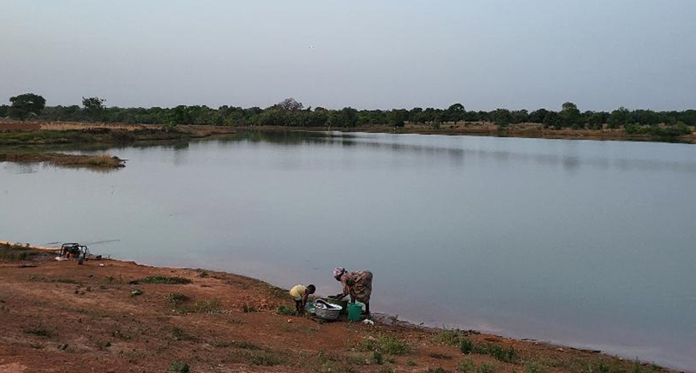

Figure 6. Washing activities and irrigation using a water pump at the Langbensi dam.

## **NANSONI DAM**

The Nansoni dam is found in the Nansoni in the Chereponi district. A total of 7 seven people were interviewed. This comprised 4 females and 3 males. Other nearby communities that benefit from water from this dam are, Akromabila, Nandere, Kpenchi, Angor, Eteli, Tumpondi, and about 25 other communities.

### **RESERVOIR CHARACTERISTICS**

The construction of the dam was funded by Action Aid in the year 1998. It is owned by the community and managed by the chief, the elders, and the water management committee. Since its construction, the dam has not dried up completely and is liable to flooding in the rainy season but does not overflow its abutment. The estimated depth of the dam ranged from 7 to 60 feet. There is access to electricity but no local market in the community. The nearest market is in the Chereponi Township. Susu systems and women’s groups had the highest tally. Other community-level organizations mentioned were the self-helped groups, men’s groups, and farmers' and fishermen’s groups.

Table 5. Sample results on the characteristics of the Nansoni dam.



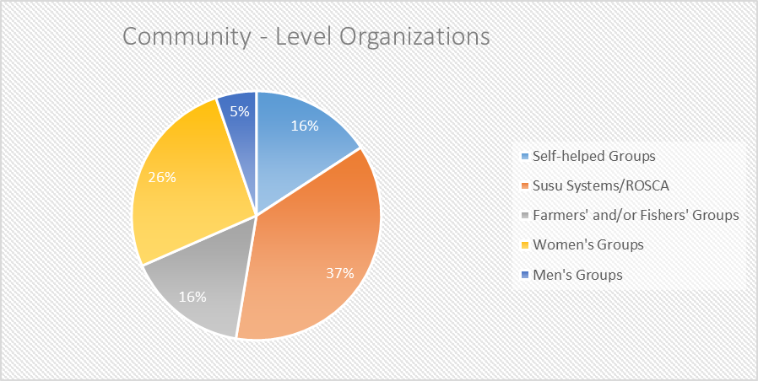

Figure 7. Percentage of responses to the community–level organization in Nansoni.

### **RESERVOIR USES AND USERS**

Irrigation of farms during the dry season, fishing, domestic uses, drinking of water from the dam, animal watering, construction purposes, and pure water business are the main uses of the Nansoni dam. Approximately 70 – 200 people visit the dam daily. Aquaculture activities have not been introduced to the dam yet. Permission is given to fishermen from the Chereponi Township and the communities to fish in the dam occasionally. Fish harvested are Catfish, Tilapia, Synodontis, Electric fish, Herrings, and Redfish. The level of security in the community is described as high.

### **RESERVOIR WATER QUALITY**

Since the water serves as a source of drinking water for the communities, measures are put in place to ensure that the dam and its surroundings are kept as clean as possible. There are no sanitation challenges and washing especially the use of detergents is prohibited. Upstream water sources, agriculture practices, and domestic uses affect siltation, and runoff from surfaces during heavy rainfall causes sedimentation.

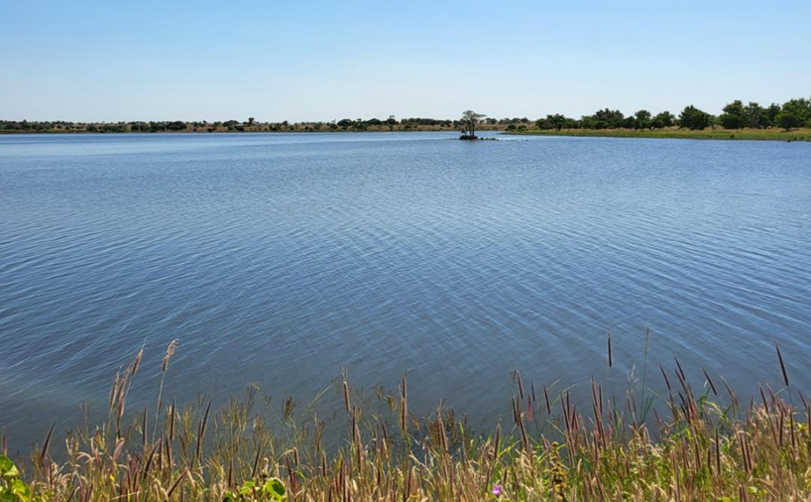

Figure 8. A picture of the Nansoni dam.

## **TOMBU DAM**

The Tombu dam is found in the Tombu in the Chereponi district. Four males and two females, summing 6 respondents were interviewed. The dam is locally referred to as ‘Kuma’. Tinchuandu, Nakaku, Tiekasu, Chombosu, and Angor communities rely on the dam.

### **RESERVOIR CHARACTERISTICS**

The dam was constructed in 2003. This was funded by the government, and Action Aid. The overlord and the village committee members oversee the management of the Tombu dam. The estimated depth ranges from 30 to 65 feet. The dam since its construction has not dried up completely at any point and it does not get flooded in the rainy season. There is electricity in the community. Half of the respondents interviewed replied ‘YES’ to the availability of a local market and the other half ‘NO’ to the same question. Susu systems and women’s groups had the highest tally. Other community-level organizations mentioned were the self-helped groups and farmers and fishermen’s groups.

Table 6. Sample results on the characteristics of the Tombu dam.



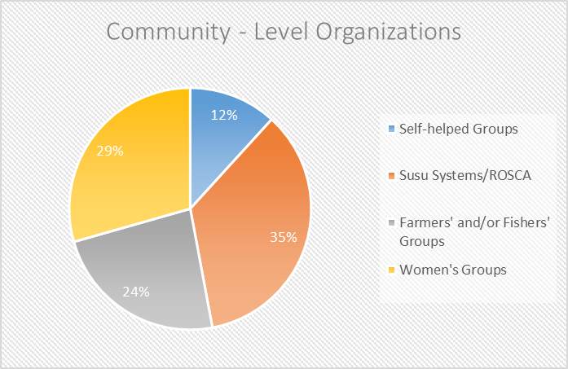

Figure 9. Percentage of responses to the community–level organization in Tombu.

### **RESERVOIR USES AND USERS**

With a minimum of 50 and a maximum of 120 daily, the dam is used for fishing, irrigation, construction, and domestic activities. There have not been any aquaculture initiatives in the dam. The community has a dam management committee that gives authorization to fishermen to fish from the dam seasonally. Fishes mostly caught from the dam include, tilapia, catfish, and mudfish. The average security level in this community is medium.

### **RESERVOIR WATER QUALITY**

There are no sanitation challenges or reports and the community does not wash clothes in the dam. Some activities that cause the dam to be silted are water from upstream sources, agriculture and domestic activities, and animal water watering. Sedimentation results from surface runoff during heavy rainfalls.

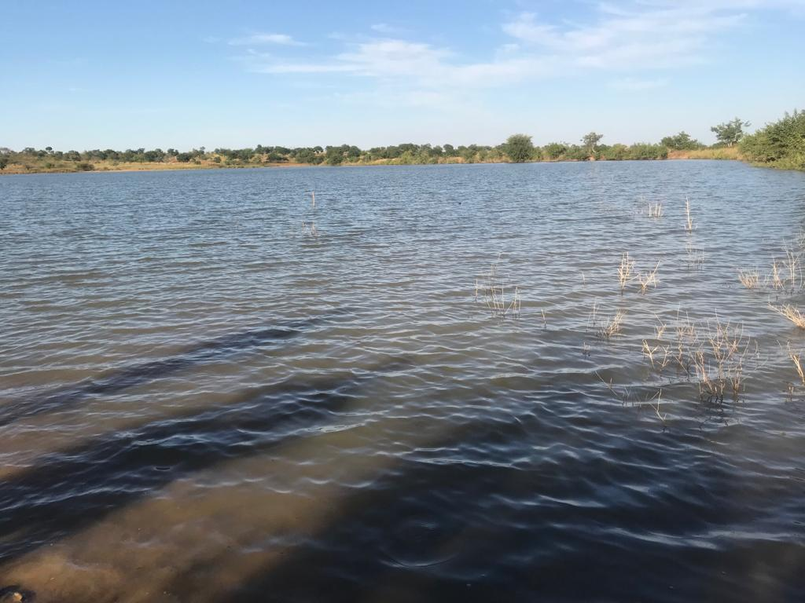

Figure 10. A picture of the Tombu dam.

## **DIANI DAM**

Diani dam is sited in Diani, a community in the West Mamprusi district. The community refers to the dam as “Diani moari” which translates to Diani River. Including the Diani community, the dam serves the Dimia, Tinkaya, Guabuliga, and Tinguri communities. A total of 5 males and 5 females were interviewed from the Diani community.

### **RESERVOIR CHARACTERISTICS**

The Diani dam constructed in the 1960s by the government is owned by the community and managed by the chief and elders of the community. The dam with an estimated depth of 20 – 40 feet does not dry up completely anytime within the year. The dam is flooded in the rainy season but not beyond its dike. There is an electricity supply in the community and the nearest local market can be found in Walewale. Community-level organizations that exist in the community are self-helped groups, Susu systems/ROSCA groups, farmers and fishermen groups, and women’s groups.

Table 7. Sample results on the characteristics of the Diani dam.



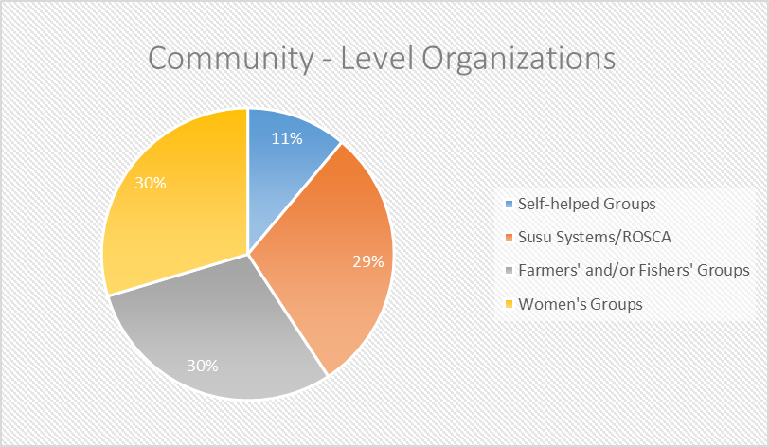

Figure 11. Percentage of responses to the community–level organization in Diani.

### **RESERVOIR USES AND USERS**

The major uses of the dam are fishing, domestic uses, irrigation, construction purposes, and animal watering. Several 20 – 200 users visit the dam in a day. For fishing activities, fishermen from other communities are contracted by the chief to fish from the dam during certain seasons of the year. There has been an initiative for adapting an aquaculture system but it is currently inactive. Security is averagely high in the community.

### **RESERVOIR WATER QUALITY**

Water quality challenges faced are the turbidity of the water from sediments and contamination of the water from animal excreta left after animals are watered. Sediments from surface runoff from heavy rainfall and soil residues from the brick construction cause sedimentation. Siltation is mainly caused by upstream water sources, brick construction, and domestic, and agricultural activities. The community of prohibited from washing close to the dam.

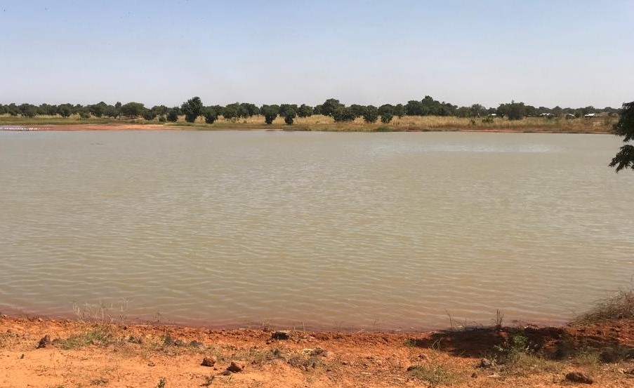

Figure 12. A picture of the Diani dam

## **NAYORKO DAM**

The Nayorko dam is situated in Nayorko, a town in the West Mamprusi district of the North East region. The dam is generally called ‘Bogbla’ or ‘Moari’ by the community. Neighboring communities, Banewa, Gbimsi, Gagbine, Kata, and Walewale benefit from the dam.

In the meeting with the chief and his elders, the team was informed of the unsuitability of the dam to be used for fish farming as the outlet of the dam is broken and the heavy siltation of the dam. Five respondents, three males, and two females were interviewed in this community.

### **RESERVOIR CHARACTERISTICS**

The Nayorko dam per the response from the community engagement was established in the 1960s. It was funded and constructed by the community with full custodians given to the community overseen by the chief and the elders of the community. The community response to the estimated depth of the dam was 5 – 20 feet. Though the chief mentioned how heavily silted the dam was, the respondent mentioned the dam not drying up completely any time of the year. Three of the respondent said the dam does not get flooded whilst the other said it floods during the rainy season. At the same rate, three responded to having no access to a local market within the community whilst two attested to the availability of a local market. Community–level organizations present in this community are, Self-helped Groups, Susu Systems/ROSCA, Fishermen’s Groups, Women's Groups, and Trade Unions.

Table 8. Sample results on the characteristics of the Nayorko dam.



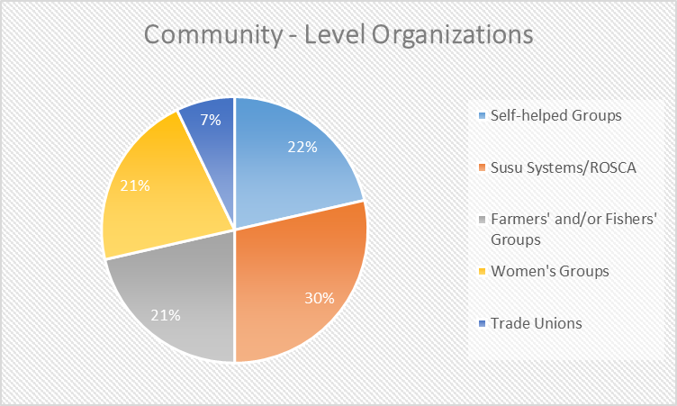

Figure 13: Percentage of responses to the community–level organization in Nayorko.

### **RESERVOIR USES AND USERS**

Several 20 – 120 people use the dam for irrigation, domestic uses, construction, fishing, and filling of water tankers for selling daily. There have not been any aquaculture practices introduced in the dam yet. The chief and the elders give authorization to fishermen groups for the community and neighboring communities to fish occasionally in the dam. Fishes normally harvested from the dam include; tilapia, catfish, Synodontis, mudfish, and others whose names are not known. The level of security in the community is on a medium scale.

### **RESERVOIR WATER QUALITY**

Aside from the turbidity of the water as a result of surface runoff from heavy rainfall, there are no sanitation or water quality challenges. The surface runoff from the rains also causes the dam to be sediment. Activities such as farming activities such as vegetable and rice farming around the dam, upstream water flow, domestic uses, and surface runoff lead to the siltation of the dam. The community is prohibited from washing in the dam.

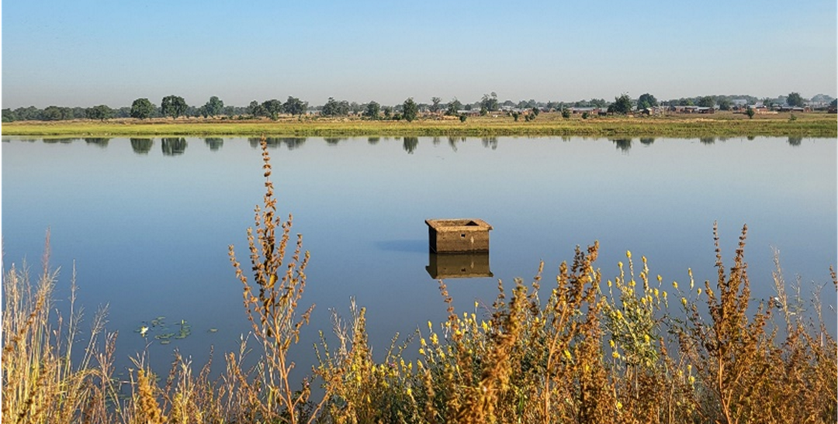

Figure 14. A picture of the Nayorko dam

## **CHEREPONI DAM**

The Chereponi dam is located in Chereponi in the Chereponi district of the North East region. The officer in charge of the dam advised that the dam will not be suitable for fish farming due to the insecurity issues in the community. He added that the dam was not kept clean, and also the dependency ratio on the dam was too high as it was the major source of water for the community. An aquaculture initiative was not advisable.

Because of this reason, only one person was interviewed in this community.

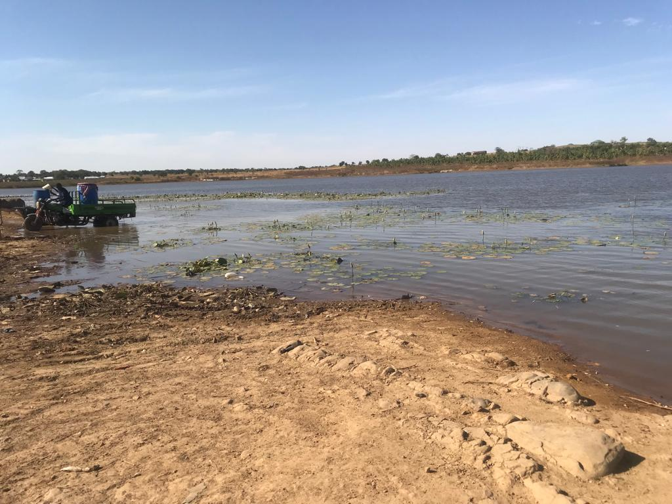

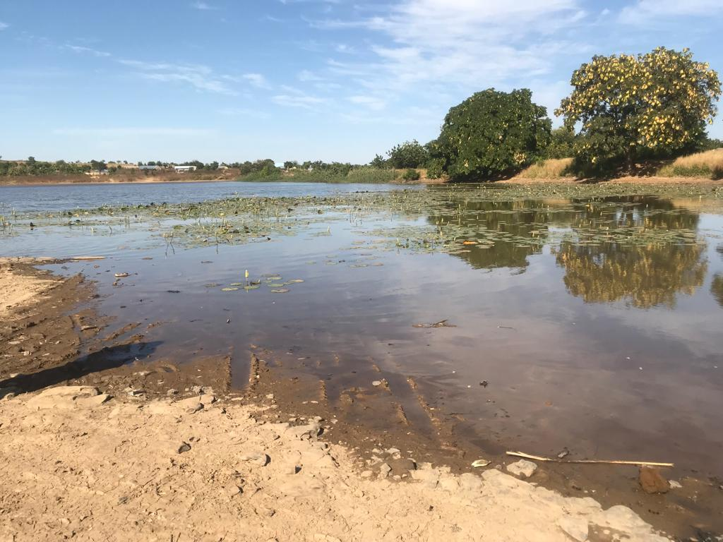

Figure 15. Pictures of the Chereponi dam